**EcoRouteCOP16**

**Por: Miguel Perez Ojeda**

**Código: A00407054**

• Start

- Welcome

• Ask the user for their name via console

- Ask user for name

• Ask for the identity number, in this case the ID

- Request ID

• Route Choices

- Select one of the 3 routes

• Meteorological data

- Request information on temperature in °C and relative humidity

• Bus calculation

- Verify that all people who take an event route go on a bus, verifying that not a single person is left out.

|  |  |
| --- | --- |
| Summary: Registration, route selection and calculation of meteorological data will be carried out. It is designed to interact with volunteers from COP 16 in Cali, Colombia. The objective of the program is to allow the user to enter their name, ID and choose one of the three ecological routes available. After choosing a route, the program requests weather data (temperature and humidity) and determines if it is a good day to walk in the city. | |
| Inputs | Outputs |
| **User Name (String): Name entered by the user.**  **ID (String): User ID without points or commas**  **Route (int): Select numbers from 1 to 3, depending on the desired route**  **Meteorological calculation (double): depending on the temperature of the day, the temperature and relative humidity are written**  **Bus Calculation (int): Depending on the number of people, it is calculated how many buses are needed so that not one person is left without a seat.** | Username (String): The user's name is displayed along with a welcome.  Routes (string): valid options from 1 to 3 are displayed, each corresponding to a specific route. After selecting this, a statement is displayed with certain characteristics of the route, such as; meeting point, departure time and arrival time  Meteorological calculation (double): the user enters the temperature in degrees Celsius °C and the relative humidity, according to these 2 a text is presented whether it is a good day or not  Bus Calculation (String): Shows the number of people attending the event and also the number of buses needed to transport the people |

**Ejemplo:**

**# Welcome volunteer to the COP 16 Ecological Routes Interaction Application - Cali, Colombia.**

**# Please enter your name:**

**> Miguel Perez**

**# Please enter your ID (without dots or commas):**

**> 1112345678**

**Welcome, Miguel Perez!**

**# Now, tell me which of the 3 routes you want to choose?**

**# Enter the number (1) to choose the Ladera route**

**# Enter the number (2) to choose the Oriente route**

**# Enter the number (3) to choose the Farallones route**

**> 3**

**# You chose the route to: Farallones**

**# Meeting point: Calle 16 - Universidad del Valle**

**# Activity start time: 6:40 AM**

**# Activity end time: 2:30 PM**

**How many participants will attend the walk today?**

**> 12**

**How many guides will attend the walk today?**

**> 10**

**# Now enter the weather data so I can tell you how the day will be**

**# Enter the temperature in degrees Celsius °C (use a comma for decimals)**

**> 25**

**# Enter the relative humidity percentage (use a comma for decimals)**

**> 56**

**# It's a good day for a walk in Cali!**

**# With a total of 22 people participating in the activity,**

**# It is necessary to have 1 bus to carry out the activity successfully. See you at COP16!**

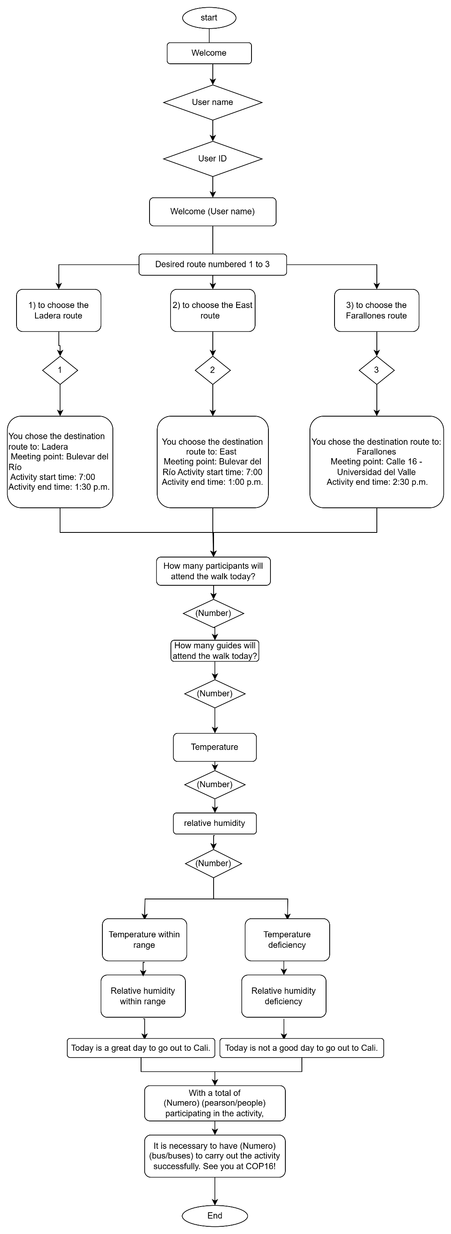**Diagrama de flujo:**

